Jenkins Shell Script
cd /var/www/html
rm -rf *
service httpd start
cp -r /root/.jenkins/workspace/jenkins_assig1/index.html .
chmod 644 index.html
Jenkins Console Output
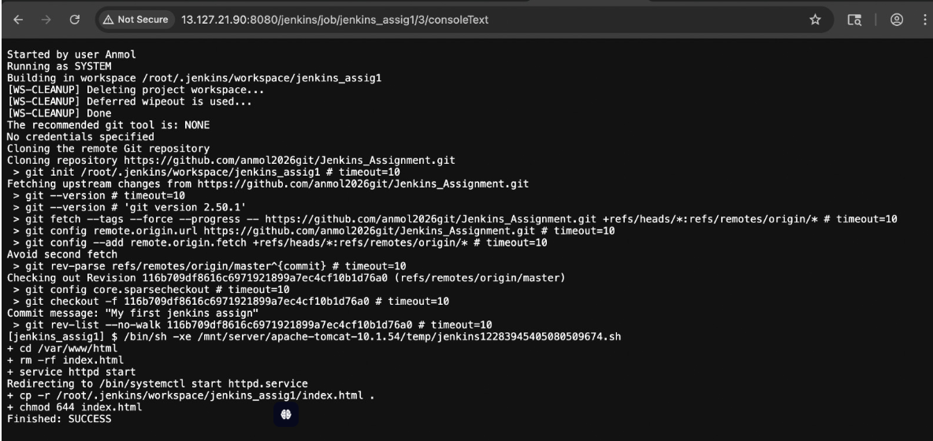
Accessing Website


